**Requirement Gathering and Analysis Phase**

**Data Flow Diagram & User Stories**

|  |  |
| --- | --- |
| Date | 29-07-2024 |
| Team ID | SWTID1720166168 |
| Project Name | Project – BookMyTrip |
| Maximum Marks |  |

**Data Flow Diagrams:**

**Simplified DFD:**

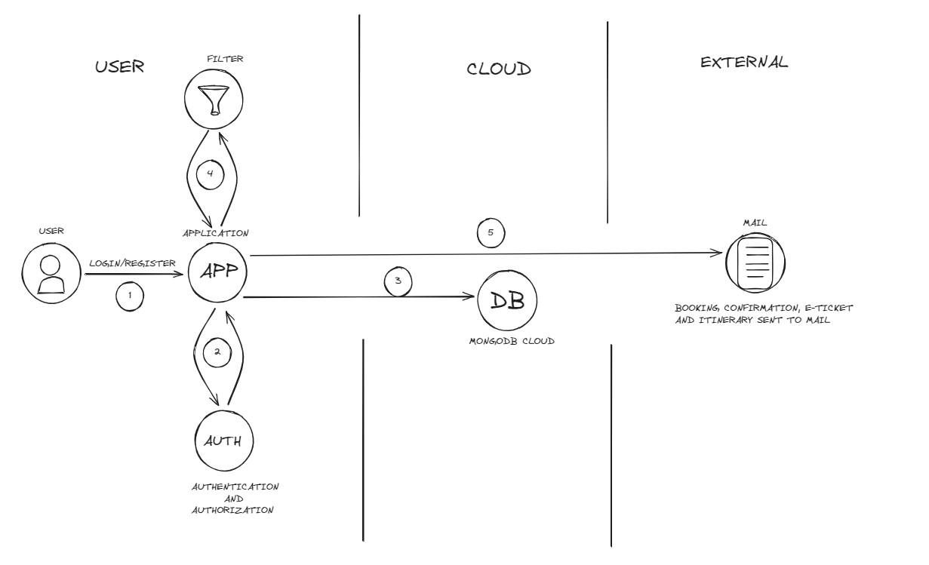

1. User registers or logs in to the app.
2. If logging in, there is authentication.
3. If registering, the data is then saved in the cloud.
4. User performs a filter to search for his required flight.
5. If user books the required flight, then the booking confirmation, e-ticket and itinerary is sent via mail.

**DFD Level 0(Industry Standard):**

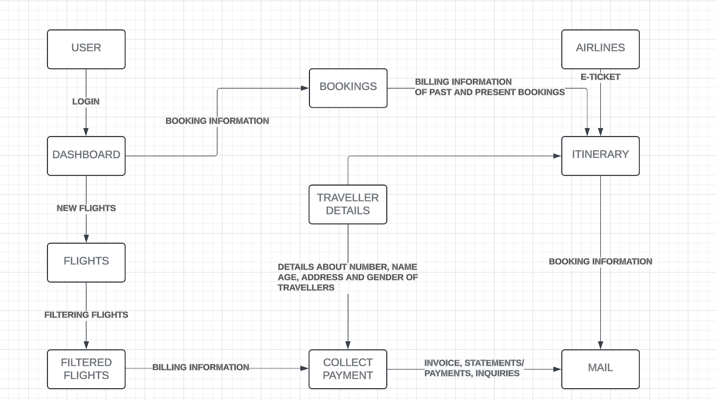

**User Stories**

| **User Type** | **Functional Requirement (Epic)** | **User Story Number** | **User Story / Task** | **Acceptance criteria** | **Priority** | **Release** |
| --- | --- | --- | --- | --- | --- | --- |
| Customer (Mobile user) | Registration | USN-1 | As a user, I can register for the application by entering my email, password, and confirming my password. | I can access my account / dashboard | High | Sprint-1 |
|  |  | USN-2 | As a user, I will receive confirmation email about the booking and receive the itinerary and e-ticket. | I can receive confirmation email & click confirm. | High | Sprint-1 |
|  |  | USN-3 | As a user, I can register for the application through Gmail and Phone number. | I can register & access the dashboard with Gmail Login or Phone number. | Low | Sprint-1 |
|  |  | USN-4 | As a user, I can register for the application through Gmail | I can register and access by Gmail login. | Medium | Sprint-1 |
|  | Login | USN-5 | As a user, I can log into the application by entering email & password | I can use the login form to log into my account using Gmail or phone number. | High | Sprint-1 |
|  | Dashboard | USN-6 | As a user, I should be able to see all my past and present bookings. | I can use the bookings option in home page’s dashboard to view all the past and present bookings. | High | Sprint-1 |
|  | Flight Selection | USN-7 | As a user, I should be able to filter out flights to my liking and preferences. | I can use the filters to select the date, timings, duration, layovers and other criteria to filter flights according to my needs. | High | Sprint-1 |
|  | Seat Selection | USN-8 | As a user, I want to be able to see the whole layout of the flight to see whether the seat I pick is near the wings and to check whether the seat I am viewing is a window, middle or an aisle seat. | I can use the seat map to see whether my seat is window, middle or an aisle seat along with seeing a faint exterior of plane for showing the position of wings. | High | Sprint-2 |
|  | Payment | USN-9 | As a user, I should be able to pay using multiple methods. | I can use the payment via UPI or via cards. | High | Sprint-2 |
|  |  | USN-10 | As a user, my payment information should be safe. | The app uses MongoDB’s database where the settings are made to ensure that usage of Secure Sockets Layers SSL and Transport Layer Security TLS are set to true. | High | Sprint-2 |
|  | Confirmation of Booking | USN-11 | As a user, I should get confirmation via SMS. | I receive an SMS regarding the status of booking as soon as I book a ticket. | High | Sprint-3 |
| Customer (Web user) | Registration | USN-1 | As a user, I should be easily able to register using a website. | I can use the registration through form, phone or Gmail to easily register for the website. | High | Sprint-1 |
|  | Login | USN-2 | As a user, I want secure login so there is no unauthorized access to my accounts. | I can use the authentication to login and authorization by Gmail for buying or cancelling tickets. | High | Sprint-1 |
|  |  | USN-3 | As a user, I want to be able to securely access my account from multiple devices while ensuring that no one is able to access my account without my permission on different device’s browser. | I can use the authentication feature to ensure that I am not only able to login from multiple accounts, but also no one else is able to login to my account. | High | Sprint-1 |
|  | Dashboard | USN-4 | As a user, I should be able to have the option to quickly book new flights with desired filters | I can use the book new flights option in the dashboard in homepage. | High | Sprint-2 |
|  | Flight Selection | USN-5 | As a user, I want to be able to sort flights based on parameters such as flight slot (early morning, morning, noon, evening and night), airlines and layovers. | I can use the filters to sort flights by slot, the airline I want to travel in as well set the number of layovers I want to have in the flight. | High | Sprint-2 |
|  | Seat Selection | USN-6 | As a user, I want to able to select my Seat based on seat type (business, premium economy and economy) as well as check their prices. | I can use the seat map to check the type of seat (business, premium economy and economy) and its price. | High | Sprint-2 |
|  | Payment | USN-7 | As a user, I should be able to pay using cards in website securely. | I can use the payment gate implemented using secure APIs for payment without worrying about leaking of this sensitive information | High | Sprint-2 |
|  | Confirmation of Booking | USN-8 | As a user, I should get the booking status, itinerary and e-ticket via mail as soon as I complete the transaction. | I receive a mail about the booking status and also receive itinerary and e-ticket if the booking was successful. | High | Sprint-3 |
| Customer Care Executive | Quick Support | CCESN-1 | As a CCE, I should ensure that my customers have a quick support in case they have a issue. | As a CCE, I have a dedicated customer care department for queries by customers. | High | Sprint-4 |
|  | Feedback | CCESN-2 | As a CCE, I should ensure that I keep track of my customers experiences and give them a means to communicate their experience in order to improve the apps according to their needs. | As a CCE, I have a feedback form for every time a user uses our app. | Low | Sprint-4 |
| Administrator | Performance | ASN-1 | As the admin, I must ensure that the app works smoothly and their no performance drops. | As the admin, I will use optimized way to store, access and query data (use MongoDB) to ensure there is no lag when using the app. I will also use **optimized functions** to handle heavy loads with minimal performance stutters. | High | Sprint-1 |
|  | Consistency | ASN-2 | As the admin, I should ensure that my customers must have their data stored consistently with no errors and data updated by them must be updated consistently everywhere the information is stored to maintain uniformity of data. | As the admin, I use MongoDB to ensure there is no data inconsistency. | High | Sprint-1 |
|  | Scalability | ASN-3 | As the admin, I should ensure that my application is scalable, to ensure that as the number of users increase, my app works fine. | As the admin, I use MongoDB as to ensure that my database is scalable | High | Sprint-1 |